Demonstrate Cyber Evasion Techniques 231901005

AIM:

Learn cyber evasion techniques and put them to the test against two IDS

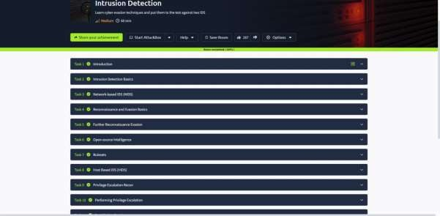

TASK 2 : INTRUSION DETECTION BASICS

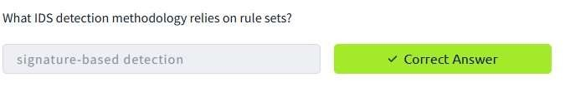

TASK 3 : NETWORK-BASED IDS(NIDS)

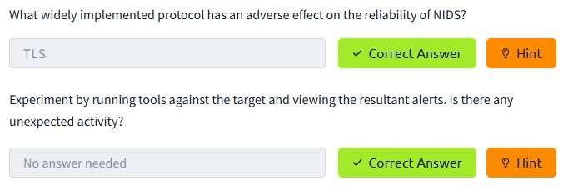

TASK 4 RECONNAISSANCE AND EVASIOM BASICS

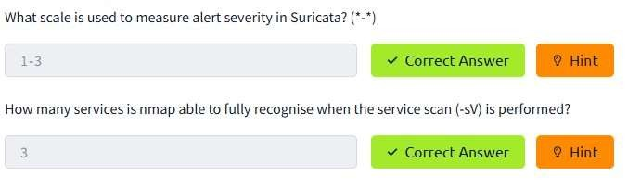

TASK 5 : FURTHER RECONNAISSANCE EVASION

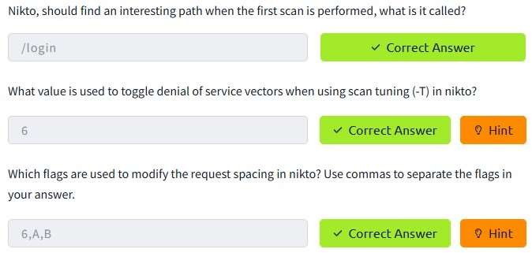

TASK 6 : OPEN-SOURCE INTELLIGENCE

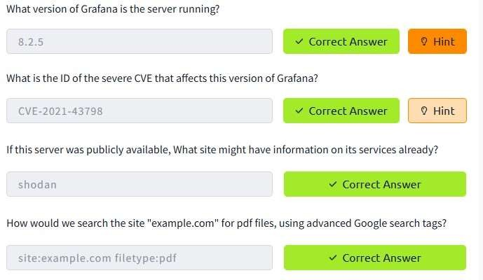

TASK 7 : RULESETS

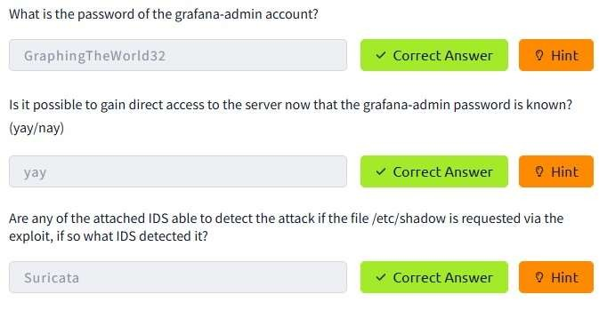

TASK 8 : HOST BASED IDS (HIDS)

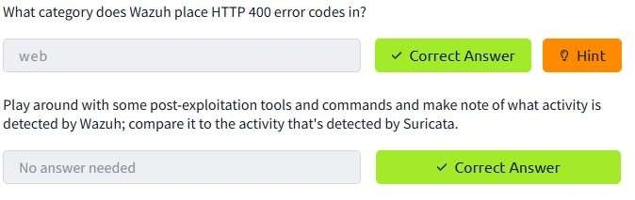

TASK 9 : PRIVILEGE ESCALATION RECON

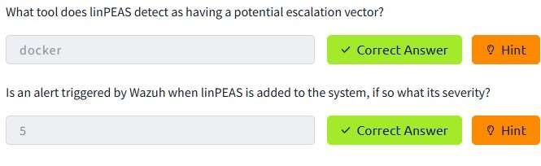

TASK 10: PERFORMING PRIVILEGE ESCALATION



RESULT :

Cyber evasion techniques and put them to the test against two IDS is successfully learned